Nama : Alfan Nur Rabbani

NIM :18090139

Kelas : 5D

**PRAKTIKUM 4**

1. Source Code

Web.php => application/controller

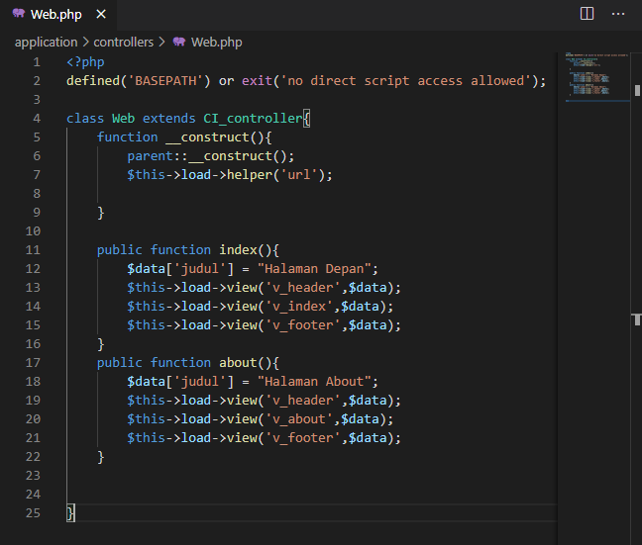

v_header.php => application/view

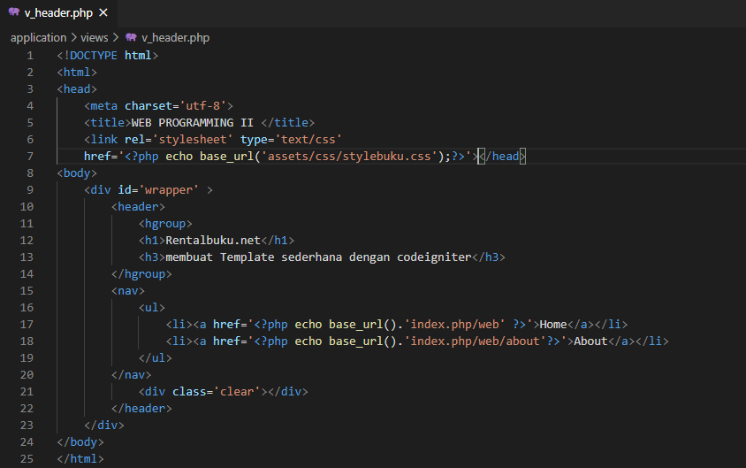

v_index.php => application/view

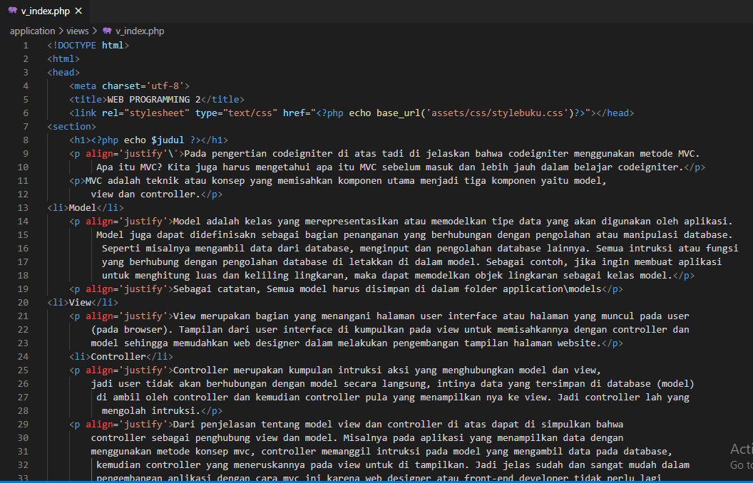

v_footer.php = > application/view

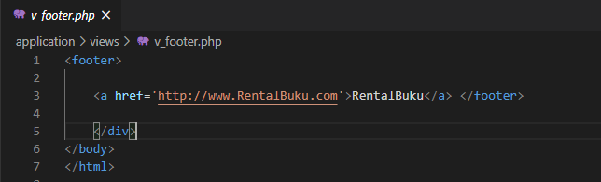

v_about.php => application/view

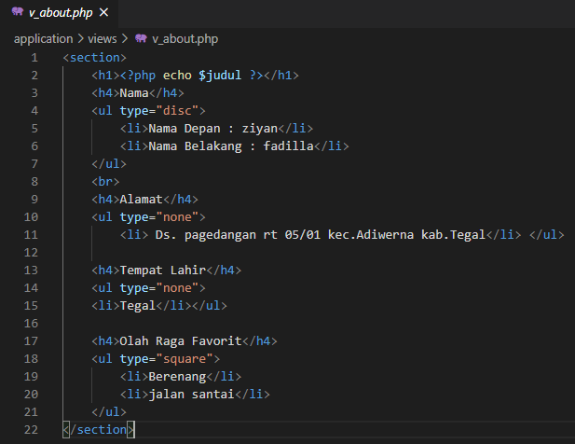

stylebuku.css => assets/css

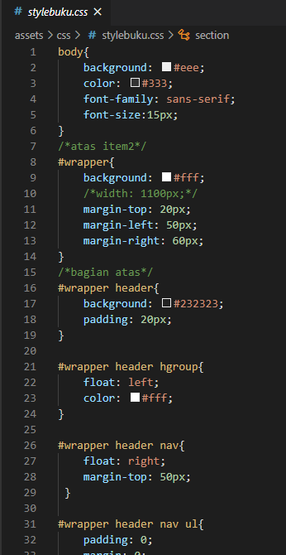

config.php => application / config

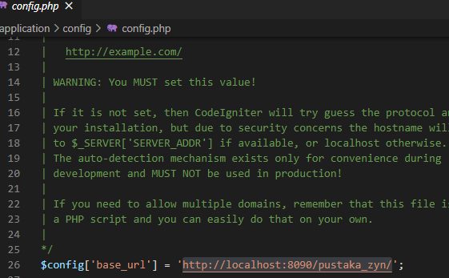

autoload.php => application / config

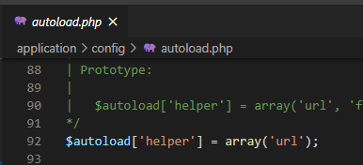

1. URL
2. <http://localhost/pustaka_alfan/index.php/web>
3. <http://localhost/pustaka_alfan/index.php/web/about>
4. Capture Hasil
5. Home

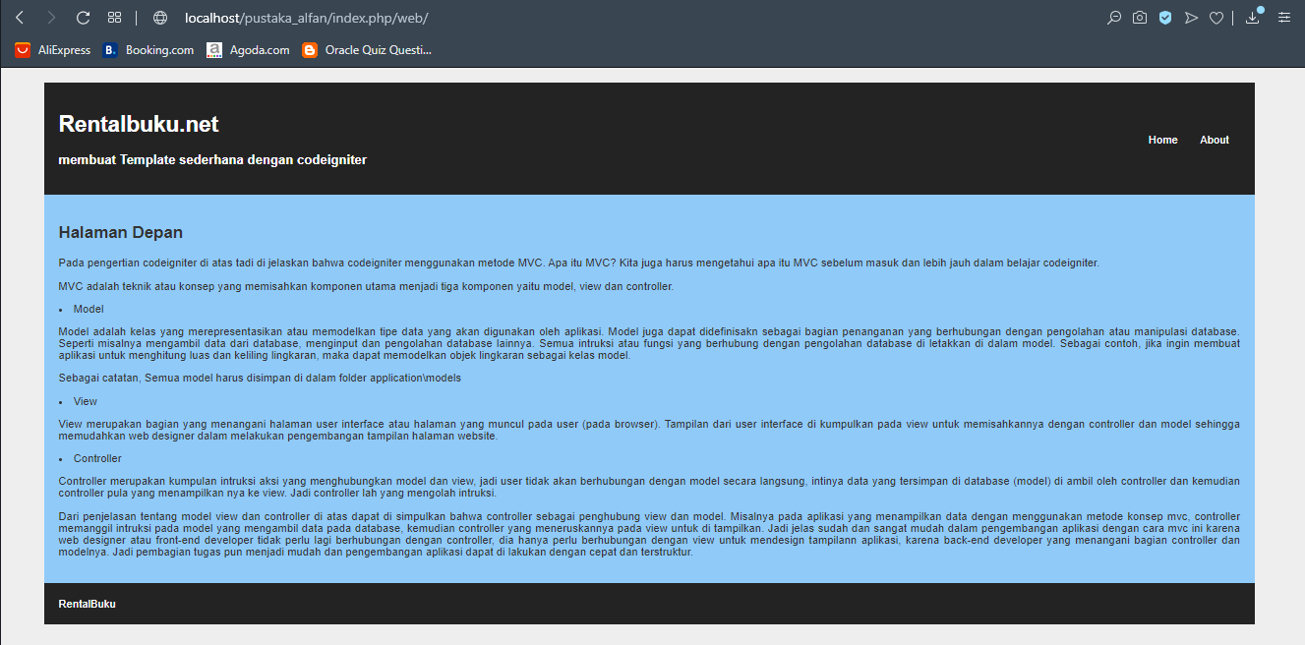

1. About

